LOB’s means File. There are two types of LOB’s.

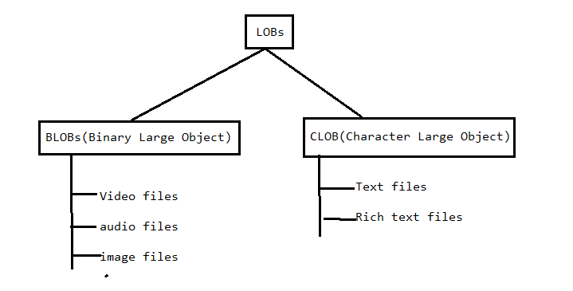

**UseCase:-**

**We need to insert photo content and bio-data content into DB table and we need to retrieve the photo content and bio-data content from Matrimony application(shaadi.com), job portal web sites(Naukari.com), social networking apps(facebook.com)**

Oracle DB s/w gave two data types for LOBs.

1. BLOB

2. CLOB

Note: -

1. Stream always points to file.

2.we can not pass stream/file content as SQL Query input value Directly. Therefore we should not use **simple statement object** to insert LOB content in DB table.

3. we can insert LOB content in DB table using prepared statement object because we can set Stream representing file as query param value using setXXX(-,-) methods.

3.1 setBianryStream(-,-)

3.2. setBlob(-,-)

To set stream which points to Blob(files) to SQL query Param, invoke one of above two methods.

3.3. setCharacterStream(-,-)

3.4. setClob(-,-);

To set stream which to points to Clob(files) to SQL query param invoke one of above two methods.

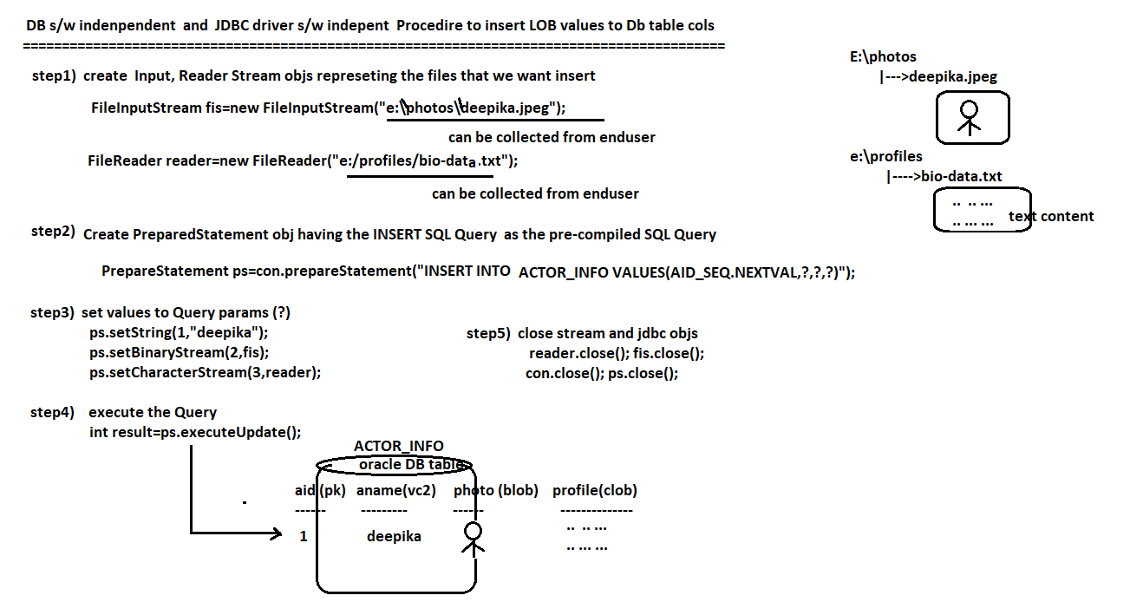

**II. Procedure to retrieve LOBS from DB table:**

Once the SQL query is executed on DB table that have LOBS, then we get result set. The Result set have streams which points to LOBS. The JDBC application invokes the following methods to get streams.

1. getBinaryStream(int Index);

This method returns the InputStreamObject reference which points to the BLOB.

1. getCharacterStream(int index);

This method returns the Reader Object reference which points to CLOB.

Note: we can’t display LOB content on console directly. Therefore we need to copy LOB content(file Content) to another file. We have Third party library called **Commons-io**  api which provides the IOUtils.copy(-,-) method to copy source file data to destination file data.

Syntax:

IOUtils.copy(InputStream var1, OutputStream var2);

Var1 points to source file.

Var2 points to destination file.

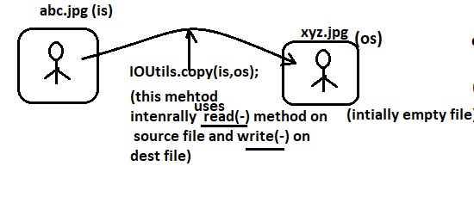

We can download the Commons-io api from following URL:



